S3/4: Discovering Epigenetics – The Epigenetic Clock
Background on Epigenetics [slide 3]
There are 50 trillion cells in your body and they all have the same DNA sequence, which contains all the necessary information for life and consists of a sequence of four different bases, the building blocks of DNA: A, T, G and C. Despite all having the same DNA, each cell type looks and behaves very differently.

Many of the differences between cells in our body arise due to epigenetics. Epigenetic marks are chemical tags that are added either to the DNA sequence or to the histones, proteins which the DNA is wrapped around. The addition of epigenetic marks onto sections of the DNA control which sections, known as genes, are switched on and off. As such the epigenetic marks play an essential role in the development and function of our body from when the sperm meets the egg at conception.

There are different types of epigenetic marks, but the best understood is the attachment of a methyl group (CH₃) onto DNA, known as DNA methylation. This always happens on a ‘C’-base of the DNA. The addition
of this group makes the DNA difficult to access, acting as a signal to switch off a gene. Though chemical tags like methylation define how the DNA is interpreted, they do not change the DNA sequence. So besides your genetic code, you have an epigenetic code of all the different markers in your body that can influence how you age and tell researchers more about how you are ageing.

Background on biological and chronological age [slide 4]

What is chronological age?
The chronological age is the time elapsed since someone’s birth, the one celebrated at with birthdays. It is the accumulation of time passing by.

What is biological age?
The biological age measures the wear and tear of the body. It provides a read-out of how healthy someone’s body would be and as such gives a more accurate prediction of ageing.

Why identifying the difference?
The chronological and biological age can be expected to be similar under “normal” circumstances, but can change due to interventions. It is interesting to understand what this difference is and how it is caused as it can explain why some people age more healthily than others. I.e. the biological age will be lower than the chronological if you are ageing healthily and the biological age will be higher if you are ageing less healthily

The Epigenetic Clock [slide 5]
Epigenetic changes are seen in many age-related diseases such as cancer, diabetes, neurodegenerative and cardiovascular disorders. Recent research has uncovered specific points in our DNA that show age-related epigenetic changes. Some of these places are conserved, meaning that they have been found across different species (for example, present both in humans and mice). At these places changes to the epigenetic code can occur, for instance DNA methylation can be gained or lost.

At the Babraham Institute we have developed a computer model called the Epigenetic Clock. It is a model that can calculate the biological age of mice with an accuracy of ± 3.3 weeks. The model calculates the biological age by looking at 329 specific sites where DNA methylation is gained or lost in a particular way with increasing biological age. It is very exciting that the model only uses 329 sites, as there are 23 million sites where DNA methylation changes can occur. The smaller number makes it more feasible for research studies.

The chronological and biological age can be expected to be similar under “normal” circumstances. However, due to certain lifestyle interventions the biological age can differ from the chronological age. The interventions affect the methylation changes and result in a different read-out from the Epigenetic Clock. If the biological age is higher than the chronological age, the mouse is ageing faster and if the biological age is lower, because of positive interventions, the ageing process is occurring slower.

Being able to use the Epigenetic Clock means that researchers can test the effect of diet, lifestyle and pharmaceutical interventions on the rate of ageing. As the Epigenetic Clock is a computer model, we can use data not only from experiments carried out in our laboratories, but also generate new information on ageing by analyzing data from previous studies.

The development of the mouse Epigenetic Ageing Clock at the Babraham Institute now provides us with a model system to study the mechanisms behind ageing and may identify new ways to treat chronic health conditions.

Background on the principal activity

[slide 6] The students have three different cards. Each card contains two mice, one is a control mouse, and the other mouse has one of the lifestyle factors changed. The students will discuss in small groups what they think the effect of the change will be to the biological age of the mouse; will it be higher or lower than the control mouse?

The Babraham Institute has investigated the effect of several factors using the Epigenetic Clock computer model. These studies covered the following factors:

Diet Fat Content: Mice fed a high-fat diet (58% of the calories were derived from fat), but the total calorie intake did not change. The main source of fat is coconut oil.

Calorie Intake: Mice fed a diet where the total calorie consumption was gradually reduced (up to 40% lower),
but the nutritional balance did not change.

Response to Growth Hormone: Mice modified with reduced response to growth hormone, which affects
their body size and life expectancy. The mice used were knockouts for growth hormone receptors; this means that the genes that are encode the growth hormone receptor proteins are altered such that the mice are not able to make a functional receptor.

[slide 7] Show video clips to discover whether the students have correctly predicted the effect of the different lifestyle factors. There is a video available for each card that shows the outcome of the biological ages.

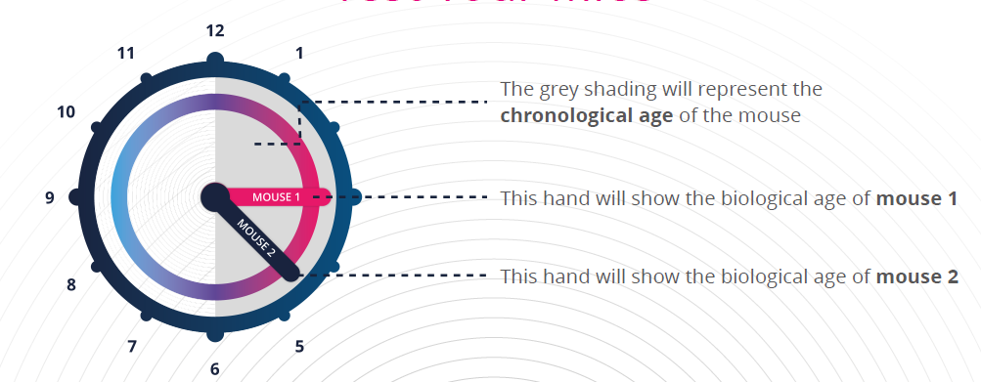

[slide 8]

The outcomes of the three different cards were:

 | Mouse 1 | Mouse 2
Blue card | 6.5 months | 6 months
Orange card | 6 months | 3 months
Purple card | 6 months | 4 months

The next steps for researchers is to better understand why certain factors slow the ageing process down or speed it up. When we understand it on a mechanistic level, we might be able to identify new treatments.

It is important to emphasize in this activity that the lifestyle factors were tested in mice, not in humans. As such, the outcomes cannot be expected to be the same in humans (we do not encourage anyone to limit their caloric intake). A healthy life consists of more than diet. The research is meant to support the understanding of ageing and we hope at some point that research conducted with the Epigenetic Clock can support humans in identifying a lifestyle that has positive effects on their ageing.

