Discovering Epigenetics - Making your Mark

Run your own ChIP-Seq experiment:

- Print both versions of the board (A2; 42cm x 59.4cm)
- Print DNA strip onto A4 sheet, cut it out stick it together.
- Stick on numbered cotton reels to represent nucleosomes
- Follow the instructions on the board:
  - Wrap your DNA twice round each nucleosomes from 1 to 8
  - Cut DNA ribbon each side of the accessible (pink) nucleosome
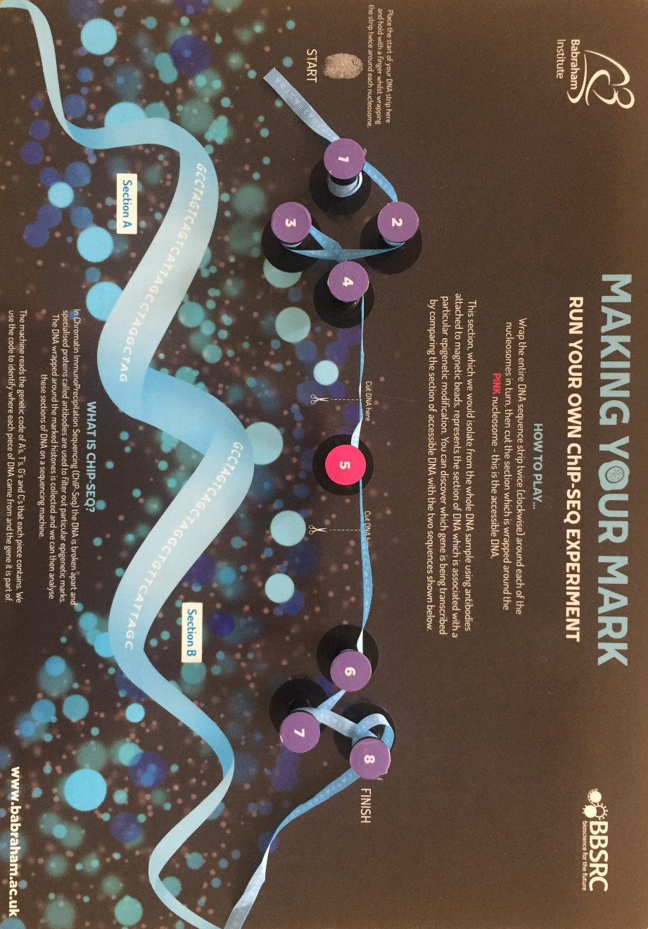
  - Unwind the cut section of DNA and compare it with the two sequences on the game board
  - Identify which of the two genes is being transcribed

