Babraham Institute Animal Facility Challenges:
Open animal unit design

Conducting research using small animals constitutes a vital component of the scientific work we do at Babraham. We have a duty under UK legislation, (the Animal (Scientific Procedures) Act, 1986), to be compliant at all times (with the Act) and the associated Codes of Practice, which include ensuring the security of the facility both from access by non-authorised personnel and from contaminants (viruses, bacteria, wild rodents, etc.)
https://www.gov.uk/guidance/research-and-testing-using-animals#animals-scientific-procedures-act-1986

Conversely, under the Concordat on Openness, we are keen to show our animal care facilities to interested members of the public. This allows them to see the high standards of care provided, the sort of environment the animals live in, the effort we put into ensuring the wellbeing and needs of the animals are met (environmental enrichment, etc.). Furthermore, it highlights our desire to further the 3Rs (Replacement, Reduction, Refinement).

http://concordatopenness.org.uk/
https://www.nc3rs.org.uk/
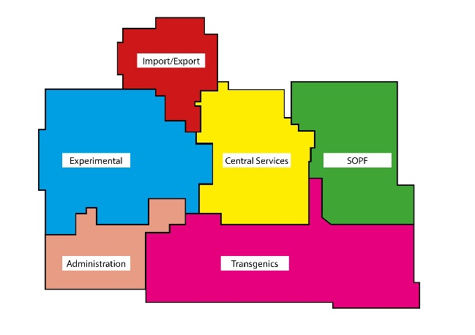

Issues:
People entering an animal care facility may bring with them rodent viruses and other contaminants. These could jeopardise the health & wellbeing of the animals and impact adversely on the important research being conducted in the unit. How could you allow the public to view areas of an animal care facility but minimise or even eliminate the risk of introducing disease?

Some members of the public may have allergies to rodents or other animals, how would you ensure they can safely view the animal facility?

What areas of the building do you think the public will be impressed by?

Which areas do you think they will be least interested in?

Do you think they ought to visit as much of the building as possible?

Will visiting these areas cause disturbance and affect the animals, the daily work regime of the care staff or the research being conducted? What would you do to minimise these risks?

How would you protect the identities of staff and scientists that may be concerned about being identified as working in animal research?

Your Challenge: Taking the above points into consideration, either adapt the existing design of the Babraham Institute animal unit (see image) or design a new building to allow members of the public to visit in order to reassure themselves on the standard of care and welfare provided.

https://www.babraham.ac.uk/science-services/biological-support-unit
https://en.wikipedia.org/wiki/Five_freedoms

