Babraham Institute Animal Facility Challenges: Cage checking

The Babraham Institute’s state-of-the-art Biological Support Unit (BSU) provides housing and care for up to 50,000 pathogen-free rodents used in both the academic scientific research programmes and by private companies. http://www.babraham.ac.uk/science-services/biological-support-unit

The Institute has a duty under UK legislation – the Animals (Scientific Procedures) Act 1986, to check the animals in our care at a minimum of once daily, every day of the year, to ensure their welfare. This is an absolute minimum frequency of checks. Additional checks on availability of food, access to water and environmental enrichment are carried out every day.
https://www.gov.uk/guidance/research-and-testing-using-animals#animals-scientific-procedures-act-1986

As you can see from the photographs, cages are housed in holding racks at various heights. On the lower levels issues arise for the technicians performing the checks. In order to view fully into these cages technicians have to either bend down or sit, kneel or lie on the floor (as shown on the photographs). This presents the risk of injury to the technicians.

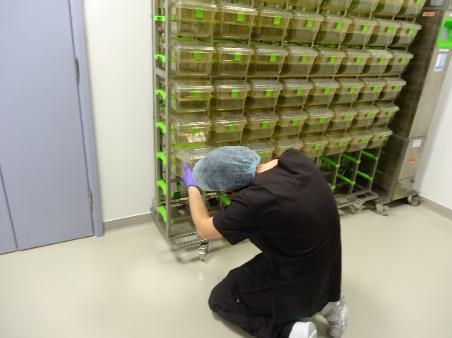

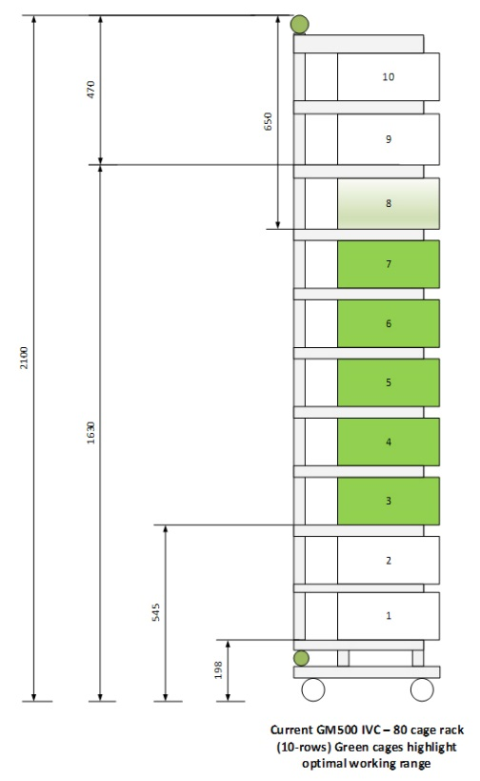
The top rows of cages can also be difficult to look into, though footstools or small ladders can allow technicians better access.

The rack is 2.0m high, 1.75 wide and 50cm deep. Each cage is 16cm high, 20cm wide and 38cm deep.

Measures that are currently in place to manage the issue:

Where space allows we avoid using the lower rows
Where lower rows need to be used then personal protective equipment is provided (kneel mats/pads)
Where upper rows need to be used then foot stools or small ladders are provided

Your challenge: Design a solution to allow the food and animal health in the top and bottom rows of cages in a rack to be efficiently checked with the minimum of risk to the technician. An alternative solution to avoid using footstools and ladders should be considered.

